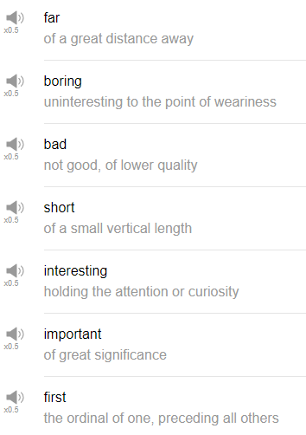

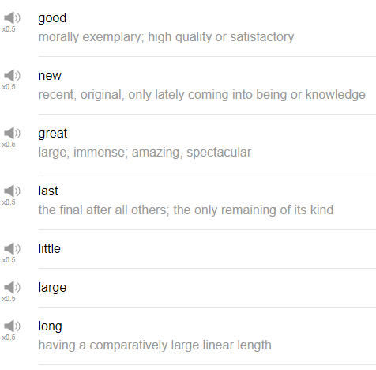

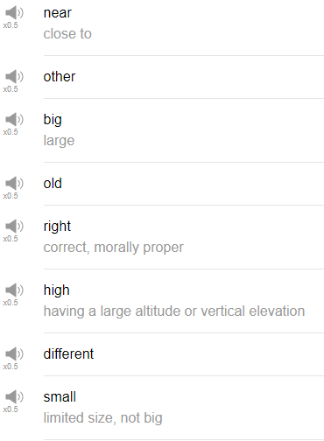

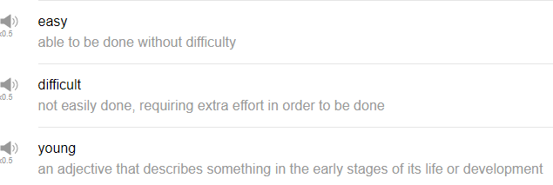

|  |
| --- |
| Hi everybody, my name is Alisha and today we are going to be talking about the top 25 English adjectives. So these are the top 25 English adjectives in terms of how often they are used. So let’s get right into it. |
| 1. Okay the first adjective is the word “good”. |
| Good can be used to refer to anything that you think is good or great or positive. In the comparative form, it is better. In the superlative form, it is best. So I think pizza is good. I think that sleep is good. I really think that sleep is good. Baseball is good, playing sports is good, video games are good. |
| 2. The next word is “new”. |
| Comparative form newer, superlative form newest. I have a new haircut, do you want a new bike, I need to get a new job. |
| 3. So next one is “first”. |
| First just refers to the number one of something. Yeah the original of something. You could say the first silent film or the first movie I ever watched or the first CD I ever bought. The first CD I ever bought was Michael Jackson’s band. |
| 4. Next word is “last”. |
| The final of something. We use last to refer to the most recent of something as well as in the last time I went to the beach or the last time I went to the forest or the last time I saw my friend. Have you ever eaten the last piece of pizza when you weren’t supposed to? What was the last word we talked about. It was first. |
| 5. The next word is “long”. |
| Long, anything that you feel is – lightsabers are long, subway sandwiches are long. I'm sorry. I'm not supposed to laugh for long. |
| 6. The next word is “great”. |
| Great can be used to express any positive emotion. Somebody gives you new information and you think it’s good but you want to express that it’s even better than good, you can say it’s great. Greater is the comparative form, greatest is the superlative form. The greatest invention of all time was a light bulb for example. |
| What do you think is your greatest achievement? One of life’s greatest pleasures is finding people to be good friends with. It’s great. |
| 7. The next word is “little”. |
| This is a very common word that gets used in an expression like when I was little for referring to when you were a kid. So when I was little, I really like to play outside or when I was little, I was really into Pokémon. I have said very little about the very little. |
| 8. The next word is “near”. |
| Near, nearer, nearest. You probably know the location of the nearest maybe a supermarket to your house and the nearest post office. I live near a very fashionable store. |
| 9. The next word is “big”. |
| Big is used for anything that is large in size or large conceptually. So for example, you can say an elephant is a big animal or in terms of concept, you can say let’s see, that fashion is really big right now or that artist is really big right now and that refers to popularity. Big movies are exciting to watch with friends. Do you have any bigger sandwiches? I am really hungry. |
| 10. Next word is “other”. Other just refers to something else, something different from what is currently happening, the other thing, the other person. My other friend is a DJ, my other friend is a cook, my other friend is a dancer, my other friend – I have really interesting friends. What other things have you done with your life? |
| 11. The next word is “old”, old. |
| It can be used to refer to people, it can be used to refer to animals, to art. Anything that has a long history. So maybe I like old movies or I don’t like old art or I think my grandpa is really, really old. He has been getting old. |
| 12. The next word is “right”. |
| This can be used to refer to the direction, right as in the opposite of left or it can be used to refer to something that is correct. So in a sentence like you are right, it means you are correct. That is the correct answer. It can also be used to mean right as in make a right turn but you will have to listen to the context to decide which meaning is the true meaning. This is not right, it could mean something that’s not fair or that you disagree strongly with. This is not right. |
| 13. The next word is “high”. |
| High refers to something that is very tall, very – way up somewhere. So many people might say like I have a fear of high buildings or I have a fear of high places. It can also in the comparative form just refer to something higher or taller than something else. Highest meaning the most high. I like high volume music. |
| 14. The next word is “different”. |
| not the same as something else is different. I think that having many different friends is a lot of fun. Do you enjoy listening to different kinds of music? |
| 15. The next word is “small”. |
| Small, smaller and smallest. Small and little are extremely similar. I would pretty much use them in the same way, however we don’t say when I was a small kid, we say when I was a little kid, or you can say when I was small. |
| 16. The next word is “large”. |
| Large and big are very much the same. I will say though that large is used on clothing sizes. Big is not and when we talked about big, we talked about how big can be used to refer to something that’s very popular. Large is not used to refer to something that’s popular. Large is used for sizing I feel only. So like a house can be large but it’s used to refer to like the physical size of something. Large and in charge. large, larger, largest. This is the largest hippopotamus in the zoo. |
| 17. The next word is “easy”. |
| Easy is the next word. Easy, easier, easiest. Now this is a good one that you can use any time something seems very simple for you. For example, this test is easy or that was the easiest thing I’ve ever done or I hope this test is easier than the last test. Don’t call person easy Alisha. Don’t ever call a person easy, unless you are trying to be really rude. My driving test was really easy or what’s the easiest language you’ve ever studied? |
| 18. The next word is “difficult”. |
| Difficult is something that seems hard to do. What is the most difficult thing you’ve ever had to do? The most difficult thing I’ve ever had to do was move to a different country. |
| 19. The next word is “young”. |
| young, younger, youngest. Come on guys. Younger, younger generations have a lot of new technologies to experiment with. Young – |
| 20. The next word is “important”. |
| Important, more important, most important. What is important to you? I think that practicing another language is more important than playing a banjo. I don’t have a banjo. You can find something that’s important to you and put your time into it. I think drinking a lot of water every day is important, putting on your shoes before you leave the house is very important. I have to go, it’s very important that I go. |
| 21. Next word is “interesting”, interesting. |
| Anything that you think is cool, anything that you find that makes you go ooh is something that’s interesting. I think that this type of music is the most interesting type of music. Your mom is interesting. |
| 22. The next word is “short”. |
| shorter, shortest. I am the shortest person in my class. I am the shortest person in the room. Short just refers to something that is not long. So it can refer to a size or it can also refer to a concept as in a length of time. So like I am going to travel abroad for a short period of time. |
| 23. "Bad" |
| You know I'm bad, I'm bad, you know it. Bad, something that is not good. Bad food will give you bad feelings in your stomach. You are a bad dog. Who is a bad dog? You are a bad dog. |
| 24. The next one is “boring”. |
| Something that is not interesting, something that does not make you go ooh but something that makes you go hah! The most boring story I’ve ever heard was a story about a tomato. If I don’t do anything, this will be really boring. |
| 25. “Far”, referring to distance. |
| Something that is not near to you is far. How can I go farther? Far, the farthest I’ve ever run is 7 kilometers. I am not a runner. |
| Okay that’s the end of the top 25 English adjectives. You would probably use these if you are studying English and if you haven’t, try to experiment with them and see what kind of interesting sentences that you can make up. Try to use the normal form and the comparative form and the negative form and the superlative form. You can express a lot with just these 25 words. So give them a try. Thanks very much for watching us in this lesson and we will see you again soon, bye. Cows are delicious! |